**MESD LMS Documentation – Communicate with learners through tutoring**

**Purpose**

Facilitates communication between students and teachers after school to enable tutoring to take place.

**Usage**

1. Log in as a **Senior Educator**.
2. Navigate to the course which you would like to host a tutoring session.
3. Click on the **Edit mode** button.
4. Add a new chat activity.

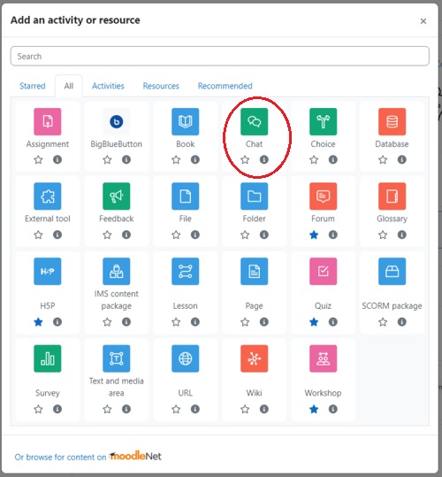

1. Create a chat room
   1. Name the chat room anything you would like. You can call it “Tutorials”.
   2. Create a description of the chat room i.e its purpose.

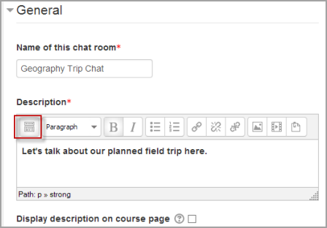

* 1. Set when you want to have the Tutorials.

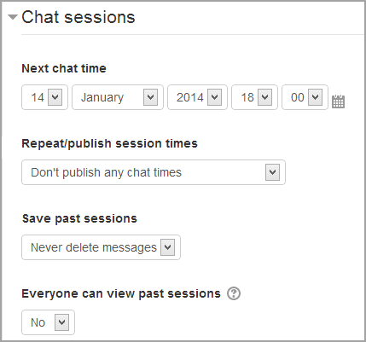

**Next chat time**

* The day and hour of the next chat session. This will appear in the calendar so students know the schedule but it doesn't stop them accessing the chatroom at any other time.
* If you don't want them in the chatroom at other times, then hide it (with the eye icon) or use [Conditional activities](https://docs.moodle.org/2x/pl/Conditional_activities) to restrict access.
* If you don't wish to schedule chat times then ignore this and choose from the next settings.

**Repeat/publish session times**

There are four options for scheduling future chat sessions:

* Don't publish any chat times- there are no set times and students are welcome to chat at any time.
* No repeats - publish the specified time only- only the Next chat time will be published. This could be used to schedule special events or meetings or simply to help learners identify a common time in which they can expect to find other learners in the chat room.
* At the same time every day- Daily chats are useful for scheduling daily office hours or work sessions with learners.
* At the same time every week--This setting will schedule a chat for the same day and time every week, which could be useful for instance for meeting and reviewing key ideas and questions related to the week’s content/assessment.

**Save past chat sessions**

* Choose from the dropdown how many days to save - or save everything by selecting *Never delete messages*
* If you have any concerns about discussions that might take place in your chat room, you may want to keep transcripts to check the suitablility of what is discussed. If your learners are using the chatroom to collaborate on a group project you won't want to delete the messages until the project is complete.

**Everyone can view past sessions**

Decide here whether or not allow everyone to view past chat sessions. (Teachers can always view past sessions).

**Restrict access/Activity completion**

If you want to you can restrict access to chat sessions by creating a group for tutorials and only adding learners who signed up to it. Then add the restriction for the chat room to be viewed only by students in that group.

1. Save and return to course.
2. When chat sessions are starting you will be notified on your dashboard.
3. To access the chat room simply enter the chat.